**HV Supports(电路边框)**

* **multilayer S2 drawing number（S2探测器图纸号）：**
  + **16,18, 26,27, 29, 30, 36,37, ,53,54, 60,61,62,63, 69,70,: one copy in one multilayer (每套做一个)**
  + **4 more for L1 and S1 （探测器L 1， S1还有四张图纸）**
* **Precision defined as peak to peak difference. （误差为最大最小偏差）**
* **Unit: millimeter（单位：毫米）**

统一误差说明（general precision description）:

|  |  |  |  |
| --- | --- | --- | --- |
| 板子厚度精度（**不包含铜皮**） | Thickness of the whole board（NOT including copper pattern） | 1.40 ±0.02 |  |
| 电路腐蚀后表面不做任何处理，厚度0.5盎司（~17微米） | **Copper pattern thickness 0.5Oz（~17micro）， no any treatment to the copper pattern after etcthing.** |  |  |
| 定位孔直径和定位长孔宽度的精度。 其他结构的位置均相对于定位孔为基准 | diameter of round positioning hole, width of the long positioning hole. positioning of all other structures are relative to positioning holes | +0.05 -0.0 |  |
| L形台阶在板材厚度方向的尺寸精度 | all L shape groove depth | 0.9+ 0.1-0.0 | See plot below left |
| 铜pad的腐蚀精度,以及相对于定位孔的精度 | Etching of copper  Pad， and  pad relative to positioning holes | ±0.1 | See plot blow right |
| 图纸中没有标明精度的一律按照 | If now specific marked on the drawing, precision take | ±0.1 |  |
| 总长度精度 | Precision of overall length | +0.0-0.2 |  |

 

0.9+0.1-0.0

特别说明：(special description)

|  |  |  |
| --- | --- | --- |
| 圆弧R2.5 的位置和转向，相对于定位孔位置精度 | The R2.5 structure below relative to positioning hole | ±0.1 |

|  |  |
| --- | --- |
| 两个4.2mm宽的开槽（如下图）深度改为 5.0, 直角处半径小于1.5毫米 . 宽度从 4.2变为 4.4mm +/- 0.10。 注意在L型槽一侧，该开口是贯通的（下图立体图） | the width of 4.2mm wide gas outlet slot change to 4.4 mm +/- 0.10, depth 5.0, the radius of the corner <1.5 . Careful to look at the 3D structure |

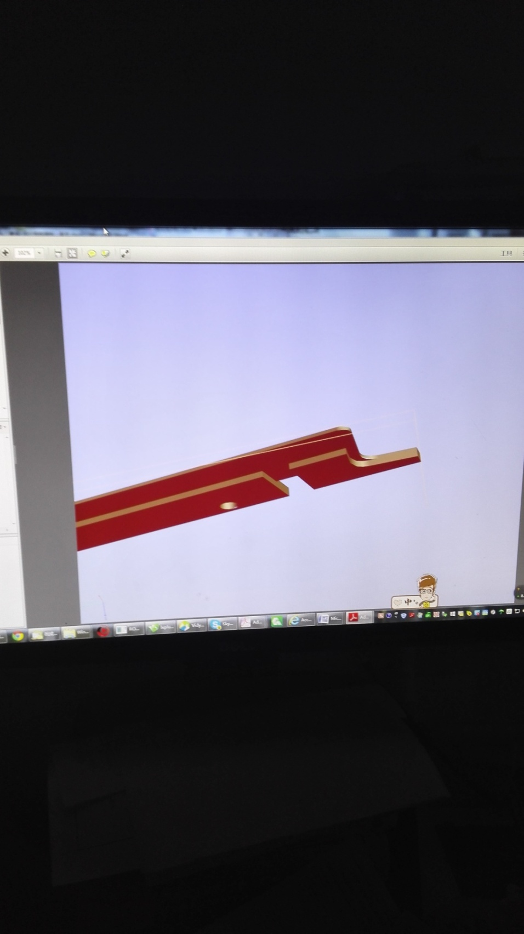

以图纸26为例（taking drawing 26 as example），



厚度（thickness） 0.9+0.0-0.1

|  |  |
| --- | --- |
| 带电路的长边框，图纸8， 30， 54，63，在边框的两端都打磨掉一个长10mm宽1mm的让位。下图上部的红圈内给出了例子，下图箭头指出了让位的位置 | For HV ruler 8,30,54,63, sand out a 10mm long， 1mm wide structure on each end.  On up part of plot below, the red ellipse show the example, on the bottom part of plot below, the arrow show the place to make the same structure. |

 

 

Materials requirement(材料要求) :

must be the tested S1142 FR4 boards from Guangdong Company. thickness 1.5-1.6mm, never less than 1.45mm.

必须采用广东生益科技股份有限公司生产的S1141 FR4板,购买的板材尺寸：厚度1.5-1.6毫米，不得低于1.45毫米