Descriptions and Requirements
Strip适配器和pad适配器加工要求

Structure requirements. 结构要求
1.1 Thefabrication is based on GERBER file, the files of other format are taken as referenceonly. | 所有加工参照其中的gerber格式图纸，其他图纸仅为参考
1.2 The board are made of layers of signal transmission line and ground. Each signal transmission line is isolated and layers of grounds are connected together to form a single ground. The impedance between each transmission line and ground is 65Ω ±10%. | 适配器为多层板，包含多个信号线层和接地层，每一根信号线和其它线路相互绝缘，所有接地层连接在一起形成模拟信号地。每一个信号线和地之间的输入阻抗为65Ω ±10%，这是最根本的要求
1.3 The width of transmission line and minimum gap between lines are 0.15mm | 信号线的宽度和信号线之间的间距最小为0.15mm
1.4 The total thickness of the board is 2.94mm in the design. If the dielectric constant of the PCB materialused is not 4.2 (4.2 is specified in the design), to keep the transmission line impedance to be 65Ω ±10%, the thickness of the dielectric PCB layer can be adjusted, which will change the total thickness of the board.If different values are used for the PCB, the impedance of the transmission line to ground should be simulated to verify that the impedance is correct | 假定绝缘层的介电常数为4.2，适配器的总厚度设计为2.94mm，如果方便使用的材料的介电系数不是4.2，为了保证信号线和接地之间的输入阻抗为65Ω ±10%，绝缘层的厚度可以适当调节，同时总厚度也会有相应的变化。进行以上的修改时，需要进行模拟以证明输入阻抗仍然满足要求
1.5 If it proves difficult to electroplate through holes on PCB boards of the specified thickness, it is permissable to usea thinner board using a higher dielectric material, reducing the total thickness of the final board. If this change is applied the impedance of the line should be respected and the issue informed. | 如果电镀通孔有困难时，允许使用较薄绝缘层，并调整介电常数，以减小板厚，但是这些改变需要在保证输入阻抗的前提下进行。
1.6 The copper weight for all the layers should be 1[oz.] (35[um]) as normally used in PCB design | 所有层的铜皮厚度均为1盎司
1.7 The PCB material should be halogen free | PCB板材料必须是不含卤素的
1.8 The through holes should be clear, free from resistive paint, such as the holes on the edge (plot below) and holes around GFZ connector. but the very small though holes (diameter <0.5mm) can be blocked by the soldering resistive paint | 边缘的通孔（如图一通孔）和GFZ插座（如图二））周围的通孔需要保持畅通，不能被阻焊漆堵塞，其他直径小于0.5mm的通孔不作要求。
1.9 The through holes without electroplating should be surround by grounding copper, and the copper should not be covered by resistive painting, to make sure the screws grounded | 不电镀的通孔用来安装螺丝，通孔周围的铜皮必须裸露，一边安装螺丝后，螺丝和铜皮良好接触。
1.10 The precision of the size (not including the thickness, which has been defined above) of the final board is +/-0.3mm | 尺寸的精度（不包含厚度）为+/-0.3mm
1.11 For the silkscreen layer no additional marks are allowed other than those on the drawing | 丝印标记不可添加公司标志，只能按照图纸设计印制
1.12 Diameter of the through hole precision +/-0.076mm | 通孔的直径精度0.076mm
1.13 Other precision refers to IPC-A-600H（2）and IPC-6012C(2) | 其他精度要求参照 IPC-A-600H（2）and IPC-6012C(2)

figure 1, the through holes on one corner of the board，版边缘的通孔

Surface Finishing 表面处理
2.1 Hard Gold finishing should be applied to the solder pads in the GFZ area (picture below in Figure 2) of 30[u inch] over Nickel. The gold surface should be of a hardness between 130[knoop] and 200[knoop] | 如图二，GFZ触点（300个小方块）需要镀镍以及硬金，硬金层厚度 30[u inch]。镀金表面的硬度应当在130[knoop] 和200[knoop]之间
2.2 Lead Free Hot Air Solder Levelling (Lead Free HASL) at the exposed ground,channels connection pads and other exposed copper on both faces of the board | 两个表面的其他裸露铜皮进行无铅喷锡
2.3 Solder mask is expected to be placed on both external faces. There is no requirement about colour, but is recommendable to use green. Thickness≥10μm | 阻焊漆喷涂两个表面，对颜色没有要求，建议使用绿色，厚度大于10个微米
2.4 The silkscreen should be placed only in the Top layer (L1).There is no requirement about colour, but is recommendable to use white | 丝印标记只在上表面，颜色没有要求，建议白色

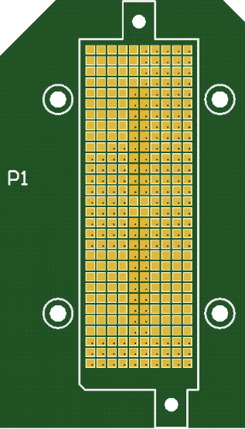
Figure 2. Finishing in GFZ pads should be Hard Gold. GFZ表面需要镀硬金

Standards Testing before delivery 质量检测
3.1 The impedance of all transmission lines to ground should be verified to be within specification. | 每一根信号线和地之间的阻抗符合上述要求
3.2 Transmission lines are isolated from each other and the ground. | 每一根信号线之间绝缘，并且都和地之间绝缘
3.3 Compliance with standard (IEC) Documents IEC-60097, IEC-60194, IEC-61189-2 and IEC-61249-2 | 符合IEC标准：IEC-60097, IEC-60194, IEC-61189-2 and IEC-61249-2
3.4 Compliance with standard (IPC) Document IPC-A-600 (newest is IPC-A-600H) | 符合IPC标准：IPC-A-600 (newest is IPC-A-600H)

