**HV Covers(光板边框)**

* **multilayer S2 drawing number（S2探测器图纸号）：**
  + **1，9，40，76 : two copy in one multilayer (每套做两个)**
  + **8: four copy in one multilayer (每套做四个)**
  + **2,91,92,93: one copy in one multilayer (每套做一个)**
  + **2 more for L1 and S1 （探测器L 1， S1还有俩图纸）**
* **Precision defined as peak to peak difference. （误差为最大最小偏差）**
* **Unit: millimeter（单位：毫米）**

统一误差说明（general precision description）:

|  |  |  |  |
| --- | --- | --- | --- |
| 板子总厚度 | Thickness of the whole board | 1.45 ±0.02 |  |
| U型槽内侧（靠近L型槽一侧）厚度 | Thickness of the inner part ( L groove side along the U-shape) | 1.40±0.02 | See plot below |
| 定位孔直径和定位长孔宽度的精度。 其他结构的位置均相对于定位孔为基准 | diameter of positioning hole, width of the long positioning hole. positioning of all other structures are relative to positioning holes | +0.05 -0.0 |  |
| L形台阶在板材厚度方向的尺寸精度 | all L shape groove depth | 0.9+ 0.1-0.0 | See plot below |
| U形槽深度误差 | U groove groove depth | ±0.05 |  |
| U形槽宽度误差 | width of U groove | +0.1-0.0 |  |
| U型槽相对于定位孔的精度 | relative positioning of U groove to positioning holes | ±0.1 |  |
| U型槽的两端形状没有要求，U型槽长度可以加长0.1~0.5毫米，但绝不可缩短。 | No requirement on the shape of the end of U groove, the length of the U-groove can be 0.1-0.5mm longer, but not shorter. |  | See plot below |
| 图纸中没有标明精度的一律按照 | If now specific marked on the drawing, precision take | ±0.1 |  |
| 总长度精度 | Precision of overall length | +0.0-0.2 |  |



1.40±0.02

1.45±0.02

0.9+0.1-0.0

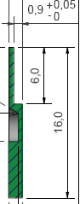

**Plot 2**

特别说明：(special description)

|  |  |
| --- | --- |
| U型槽末端直到板子的末端的1.45mm 厚度和1.40厚度的分界线改为沿着长条的长度方向，并一通到头, 下图红线 | The inter-line between the 1.45mm thickness and 1.40mm thickness changed to be parallel to the length direction of the board, and along all the length of the frame， red line below |

 

|  |  |  |
| --- | --- | --- |
| 圆弧R2.5 的位置和转向，相对于定位孔位置精度 | The R2.5 structure below relative to positioning hole | ±0.1 |



|  |  |
| --- | --- |
| 所有U形的斜坡去掉，3毫米宽的U型槽位置不变 | The U groove structure is changed as following |



|  |  |
| --- | --- |
| 两个4.2mm宽的开槽（如下图）深度改为 5.0+R, . 宽度从 4.2变为 4.4mm +/- 0.10。 注意在L型槽一侧，该开口是贯通的（下图立体图） | the width of 4.2mm wide gas outlet position change to 4.4 mm +/- 0.10, depth change to 5.0+R. Careful to look at the 3D structure |

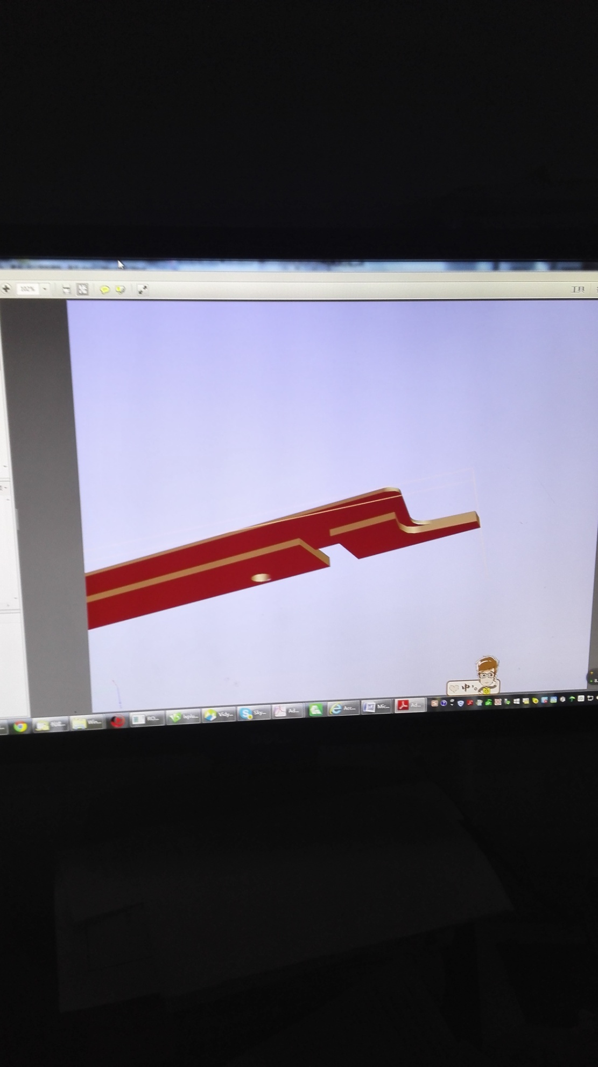

Materials requirement(材料要求) :

must be the tested S1142 FR4 boards from Guangdong Company. thickness 1.5-1.6mm, never less than 1.45mm.

必须采用广东生益科技股份有限公司生产的S1141 FR4板, 从博敏购买的板材尺寸：厚度1.5-1.6毫米，不得低于1.45毫米